**Business Intelligence**

**Project 01 – DW’s and OLAP**

**A Simple Library Management DB**

Integration, Analysis, Reporting, Excel, PowerBI

_____________________________________________________________________________

**1. Targets**

1. Know SSMS – SQL Server Management Studio
2. Design and implement a datawarehouse on SQL Server
3. Work with BIDS - Business Intelligence Development Studio
4. Create an Integration Services Project
5. Create an Analysis Services Project
6. Create a reporting Project

**2. SSMS - Management Studio: Create a database and fill it with data**

For a library management system, consider the following database of its OLTP – Online Processing System:

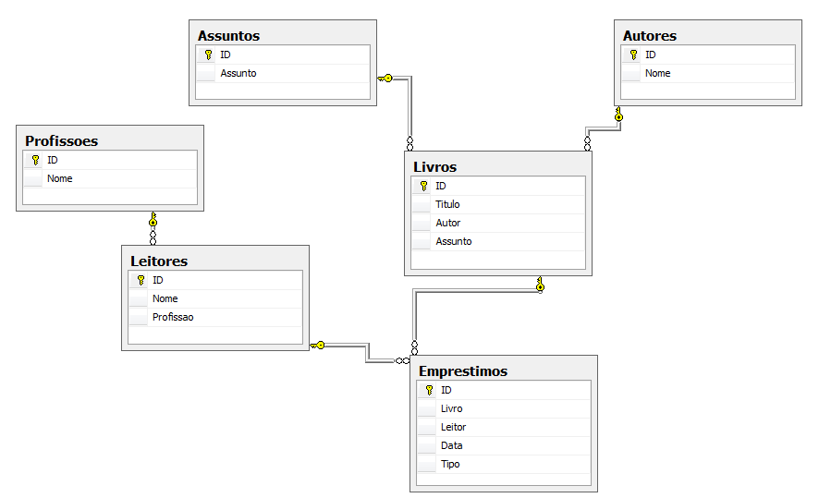

|  |  |
| --- | --- |
| Assuntos -> Subjects | Profissões -> Jobs |
| Autores -> Authors | Leitores -> Readers |
| Livros -> Books | Emprestimos -> Book requests |

Look at the database diagram and try to understand its structure, understanding the attributes and identifying the primary and foreign keys.

All the IDs are of the int type, all the strings are of type nvarchar(50) type and the date is DateTime.

Create the database, the tables, the diagram and the relationships. Then fill the tables with the following data:

Autores

Livros

|  |  |  |  |
| --- | --- | --- | --- |
| 1 | A Cidade e as Serras | 1 | 1 |
| 2 | O Crime do Padre Amaro | 1 | 1 |
| 3 | Viagens na Minha Terra | 2 | 1 |
| 4 | Análise Matemática I | 3 | 2 |
| 5 | Análise Matemática II | 3 | 2 |
| 6 | Bases de Dados | 4 | 3 |
| 7 | Datawarehouses | 4 | 3 |
| 8 | Inteligencia Artifical | 5 | 3 |
| 9 | A Musica no Tempo | 6 | 4 |

Assuntos

|  |  |
| --- | --- |
| 1 | Romance |
| 2 | Matematica |
| 3 | Informatica |
| 4 | Musica |

|  |  |
| --- | --- |
| 1 | Eça de Queiros |
| 2 | Almeida Garret |
| 3 | Piskonov |
| 4 | C.J.Date |
| 5 | Russel |
| 6 | J.Galaway |

Emprestimos

|  |  |  |  |  |
| --- | --- | --- | --- | --- |
| 1 | 1 | 1 | 12-09-2011 00:00:00 | E |
| 2 | 1 | 1 | 17-09-2011 00:00:00 | D |
| 3 | 1 | 2 | 18-09-2011 00:00:00 | E |
| 4 | 1 | 2 | 22-09-2011 00:00:00 | D |
| 5 | 2 | 2 | 19-09-2011 00:00:00 | E |
| 6 | 2 | 2 | 25-09-2011 00:00:00 | D |
| 7 | 2 | 1 | 01-08-2011 00:00:00 | E |
| 8 | 2 | 1 | 10-08-2011 00:00:00 | D |
| 9 | 3 | 2 | 03-07-2011 00:00:00 | E |
| 10 | 3 | 2 | 15-07-2011 00:00:00 | D |
| 11 | 4 | 3 | 02-08-2011 00:00:00 | E |
| 12 | 4 | 3 | 06-08-2011 00:00:00 | D |
| 13 | 4 | 3 | 06-08-2011 00:00:00 | E |
| 14 | 4 | 3 | 12-08-2011 00:00:00 | D |
| 15 | 5 | 4 | 01-07-2011 00:00:00 | E |
| 16 | 5 | 4 | 07-07-2011 00:00:00 | D |
| 17 | 5 | 4 | 08-07-2011 00:00:00 | E |
| 18 | 5 | 4 | 12-07-2011 00:00:00 | D |
| 19 | 6 | 5 | 07-08-2011 00:00:00 | E |
| 20 | 6 | 5 | 12-07-2011 00:00:00 | D |

Profissoes

|  |  |
| --- | --- |
| 1 | Escritor |
| 2 | Matematico |
| 3 | Informatico |
| 4 | Músico |

Leitores

|  |  |  |
| --- | --- | --- |
| 1 | Joao | 1 |
| 2 | Manuel | 1 |
| 3 | Ines | 2 |
| 4 | Maria | 2 |
| 5 | Carlos | 3 |
| 6 | Pascoal | 3 |
| 7 | Joana | 3 |
| 8 | Jose | 4 |

|  |  |  |  |  |
| --- | --- | --- | --- | --- |
| 1 | 1 | 1 | 12-09-2011 00:00:00 | E |
| 2 | 1 | 1 | 17-09-2011 00:00:00 | D |
| 3 | 1 | 2 | 18-09-2011 00:00:00 | E |
|  |  |  |  |  |
|  |  |  |  |  |
|  |  |  |  |  |
|  |  |  |  |  |
|  |  |  |  |  |
|  |  |  |  |  |
|  |  |  |  |  |
|  |  |  |  |  |
|  |  |  |  |  |
|  |  |  |  |  |
|  |  |  |  |  |
|  |  |  |  |  |
|  |  |  |  |  |
|  |  |  |  |  |
|  |  |  |  |  |
|  |  |  |  |  |
|  |  |  |  |  |

**3. SSMS - Management Studio: Design and Create a Datawarehouse**

We want to design a data warehouse (DW), star schema, to know the number of transactions by reader, occupation, book, book author, book subject, type (book borrow or return), each day, week, month and year. Design this data warehouse and create it using the SQL Server Management Studio.

**4. BIDS - Integration Services Project: Load the Datawarehouse (ETL Project)**

Load the library data into the datawarehouse: for this project, we will use the Business Intelligence Development Studio (BIDS). This is the name used by Microsoft for the Visual Studio environment when it is used to develop Integration Services, Analysis Services and Reporting Services projects that it offers after the SQL Server Datatools installation.

So, to create this project call Visual Studio running it as Administrator, and create a new Project of type Business Intelligence -> Integration Services Project (generally these projects are called ETL – Extract Transform and Load).

The project shall be organized into two packages:

1. Loading data into the DW dimension tables
2. Loading data into the DW fact table

Design the processes, implement and test them. Then, using the SS Management Studio and the Agent Service, schedule a day and time to automatically run the projects. Explore the possibilities of this Agent scheduling service.

**5. BIDS - Analysis Services Project: Create a Cube for the data warehouse (OLAP Project)**

We will now build an Analysis Services Project. This kind of project allows to build a cube, or OLAP – On-line Analytical Processing – application. This kind of structure, commonly named “cube”, allows the pre-processing of the data from the data warehouse, adding it along dimensions and even building new ways of computing aggregates, distinct from the usual SUM.

There are many other possibilities offered by these Analysis Services projects, such as data mining and KPI – Key Performance Indicators – definition. For now, we’ll focus on the OLAP structure only. To do this:

1. Call Visual Studio executing it as Administrator (very important!)
2. Create a New Project, type Business Intelligence, Analysis Services Project
3. Create a “cube” for the Library Data Warehouse previously designed and loaded:
   1. Create a connection to the DB and another to the DW
   2. Create a Datasource view containing the fact tables and the 2 dimension tables defined into the data warehouse
   3. For the Type Dimension, create a virtual table in this Data Source View
   4. For the Time dimension make use of the capacities specially offered by BIDS for dealing with time. Create de dimension Time and populate it with data from 2011-01-01 to 2012-12-31
   5. Verify the Dimension Usage, change what may be needed;
   6. Create the cube using the Wizard
4. Build and Deploy the project. Browse the cube to test it. Observe some other options available on Analysis Services for cube configuration and other definitions.

**6. BIDS: Create a KPI – Key Performance Indicator**

The Key Peformance Indicators (KPI) are available in a separator of the cube (Analysis Services) project. We’ll create a KPI for showing if the number of lends and returns of books, for a given month, is bellow or above the average. To do this:

1. Using the SSMS, create a query and compute the average lends and returns of books by month
2. On Visual Studio, open the Analysis Services Project before created and pen the KPI separator
3. Here you have a form where you can define all what’s needed for a KPI, including a trend symbl, if needed
4. Define it according to the average value of ends and returns above computed
5. Browse it to test if it woks!

**7. FINAL NOTICE**

You have finished the main steps for creating an OLAP project. In the next projects we’ll see how to display the data using Visual Studio Reports, Excel and PowerBI.